花蓮縣宜昌國中111年度第二學期第二次段考七年級英語科試題卷
範圍:L3~L4 考試時間:60分鐘
班級Class: 座號Number: 姓名Name: 得分 Score ____________
1.本試題卷有三大部分，總共六頁，請注意題號並記得換頁作答。
2.1-39題為單題選擇題，請以2B鉛筆將各題最適合的答案代碼畫在答案卡上。
3.第三部分為紙筆測驗，請務必使用黑色原子筆在答案卷上作答。
4.本次段考成績為紙筆測驗90分，口試10分，共100分。
第一部分:聽力測驗(1~10題，每題1分；11~14題，每題2分，共18分。)
一、辨識句意:每題均有三張圖片，請依據所聽到的句子，選出符合描述的圖片。
- (A) (B)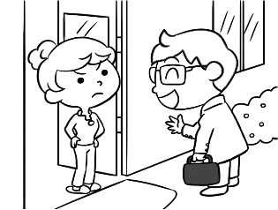 (C)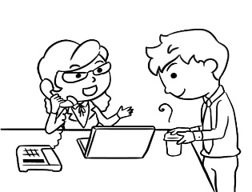
- (A)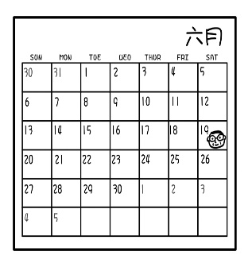 (B)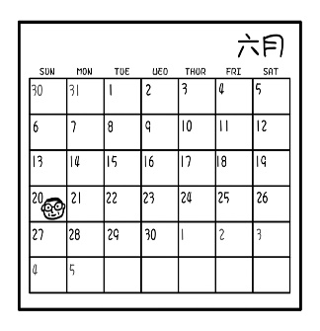 (C)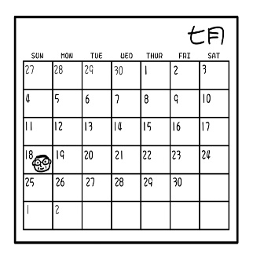
- (A)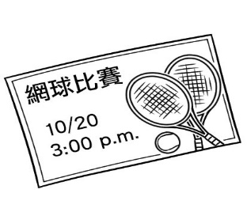 (B)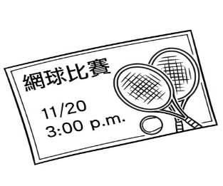 (C)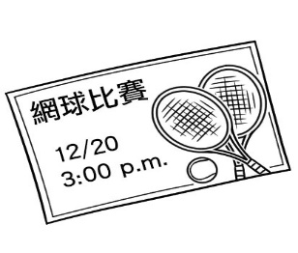
- ＿＿＿(A)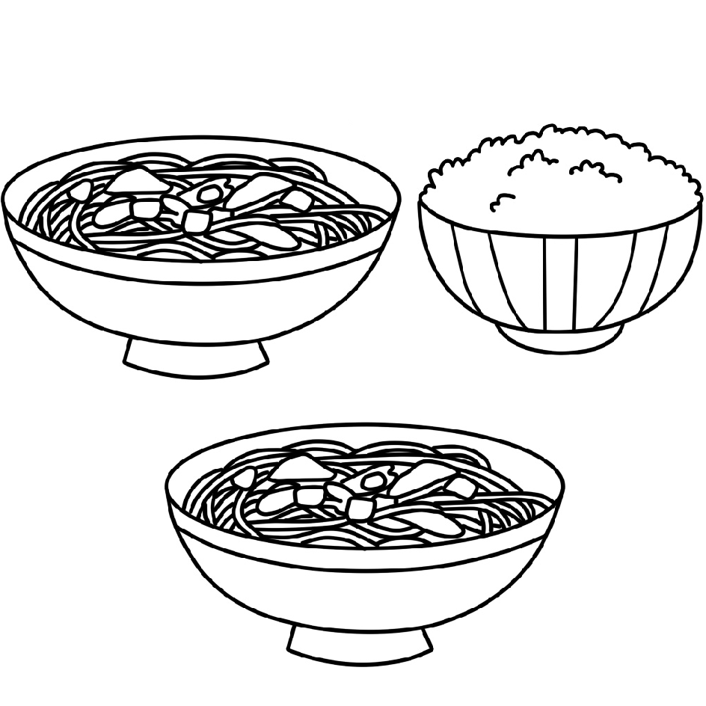 (B)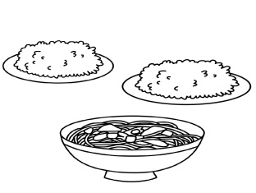 (C)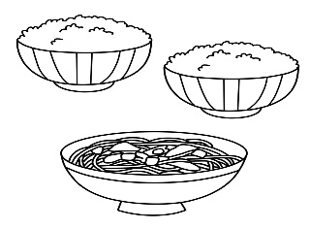
- ＿＿＿(A)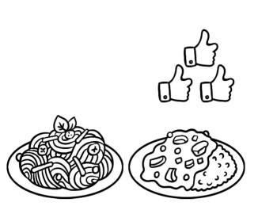 (B)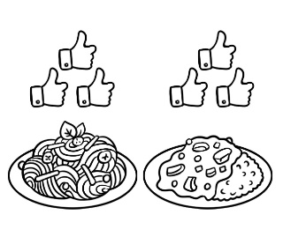 (C)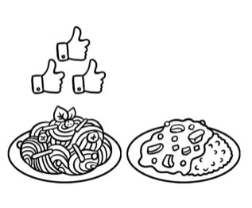

二、基本問答：每題均有三個選項，請依據所聽到的內容，選出一個最適合的回應。
- (A) No, they’re my tickets.
(B) Yes, they’re over there.
(C) No, they’re Jenny’s.
- (A) No, she really misses her brother.
(B) Yes, she talks about them all the time.
(C) No, she cares about them a lot.
- ＿＿＿
(A) Three pancakes, please.
(B) Two bowls of rice, please.
(C) On the kitchen table, please.
- ＿＿＿
(A) About six.
(B) Six, please.
(C) Six glasses are fine.
- ＿＿＿
(A) Yes, I’m thirsty.
(B) No, there aren’t any juice.
(C) Yes, there are two bottles of juice.

三、言談理解：每題均有三個選項，請依據所聽到的對話與問題，選出一個最適當的答案。
- (A) He works on Sundays.
(B) He cooks for Emma on Sundays.
(C) He takes care of Emma on Sundays.
- (A) In September.
(B) In October.
(C) In November.
- ＿＿＿
(A) Getting some papaya milk.
(B) Washing the fruit and cutting it.
(C) Adding some salt to the batter in the bowl.
- ＿＿＿
(A) At a fruit stand.
(B) At a restaurant.
(C) At a juice stand.

聽力測驗結束，請同學仔細檢查填寫的答案是否有缺漏。
第二部分:綜合測驗(共62分)。
一、單題(每題2分，共32分):下列各題請依據題意選出一個最正確或最佳的答案。
( )15. Jay: Look at the picture. The girl is holding one _____ of hot tea.
(A) bowl (B) plate (C) bag (D) cup
( )16. My sons, Ken and Henry are doctors. of them live in Taiwan.
(A) One (B) Both (C) All (D) Some
( )17. May : When does your second class start? Simon : It starts at ________.
(A) nine fifteen (B) July ninth (C) Wednesday (D) November
( )18. Mom : Nick, please give me_____ meat on the table. Nick : No problem, Mom.
(A) few (B) a few (C) some (D) many
( )19. Sandy : Whose pancake is this? Is it _______? Mike : No, it isn’t mine. It’s Cindy’s.
(A) yours (B) Mike (C) your (D) Mike’s
( )20.Teacher : Our English test is ______ 9:00 a.m. ________ Thursday. Students : Give us a break!
(A) on ; on (B) in ; at (C) in ; on (D) at ; on
( )21. Mark : _____ boxes of pork do you need, Mary? Mary : Two, please.
(A) How much (B) How much money (C)How many (D) How
( )22. Father : Is August eighth on Friday? Son : __________
(A) Yes, it is. (B) It’s on Tuesday. (C) Yes, it does. (D) Yes, it’s in August.
( )23. Sasa : The boy over there is very handsome.
Judy : _______ one?
Sasa : Look! He is playing the guitar over there.
(A) Which (B) What (C) How (D) Who
( )24. Sally : How many lemons are there in the basket?
Peter : _______
Sally : Great. Give me six, please.
(A) There are five lemons. (B) I don’t need.
(C) There are a lot of lemons. (D) How about you?
( )25. Amber : ________ Tina : Yes. Apple cakes aren’t my favorite.
(A) Are you making cakes? (B) Add some sugar to them.
(C) I need some bananas. (D) Is one piece enough for you?
( )26. Ann : Which do you like, baseball or basketball? Ryan :
(A) I don’t like soccer. (B) I like both.
(C) Yes,I like to play. (D) Can you play with me?
( )27. Nick : I am mopping the floor. It’s very dirty.
Dora: ______________.
Nick : Sure. Thanks for your help.
(A) We can play video games. (B) I am good at mopping.
(C) Let’s eat together. (D) Can I help you?
( )28. Peter : Hi, Jack. Are you OK in Singapore? Jack : Yes, I am fine. _______.
(A) Don’t worry about the work. (B) People here are nice to me.
(C) I can’t take care of my parents. (D) Here you go.
( )29. Bella : ＿＿＿ Bob: No. It’s on May 10.
(A) Is today May 11? (B) When is Eric’s birthday?
(C) What’s today’s date? (D) Is your birthday in April?
二、題組:(第30~45題，每題2分，共32分)
Jolin is a nice girl. She always does everything for her mother. One day, she helps her mother buy some things in the supermarket. The following is her shopping list.
shopping list
* one __30.___ of beef / $210 * four cans of coffee / $100
* one bottle of milk / $65 * one box ___31.___ / $110
* one bag of sugar / $25 * two ___32.____ / $150

After Jolin gets everything and goes to the cashier, she finds that she doesn’t have enough money. She is very worried. She calls her mom right away. Her mom asks, “＿33.＿” “I have only NT$425,” says Jolin. “Don’t worry. I will help you. I will be there in 10 minutes,” says her mom. Finally, they go home together. In Jolin’s eyes, her mother is a supermom. She can do everything for her.
supermarket超市 shopping list購物清單 cashier收銀臺 will將會 Finally最後
（ ）30. (A) glass (B) bottle (C) kilo (D) cup
（ ）31. (A) of orange (B) of juice (C) of eggs (D) of milk
（ ）32. (A) flour (B) boxes of grapes (C) bag of rice (D) banana cake
（ ）33. (A) What do you want? (B) Is it expensive?
(C) How much money do you have? (D) Which one do you buy?
Delicious Cake
Johnny : Hello! Friends. I’m Johnny. Today we will make a delicious cake together.
Alan : Great! How do we make it?
Johnny : First, let’s ＿34.＿ three hundred grams of flour, three eggs and some milk in a bowl.
Judy : ＿35.＿ butter do we need?
Johnny : Thirty grams is enough.
Alan : OK, thirty grams.
Johnny : ＿36.＿ we add three spoons of sugar, some salt, and some lemon juice to the cake. Then mix them three minutes, and pour it to the mold.
Judy : OK. ＿37.＿
Johnny : Let’s put the cake into the oven and bake it for forty-five minutes.

(After forty-five minutes)
Johnny : Now, we can take the cake out of the oven. Wait for about five minutes.
Judy：Making cake is very easy.
Alan：You can say that again! ＿38.＿ I can’t wait to take a bite now.
Johnny：Ha.Ha….Enjoy!
gram 公克 spoon匙 mold 模具 oven 烤箱 will將會
（ ）34. (A) meet (B) mean (C) mix (D) mop
（ ）35. (A) Is there (B) Are there (C) How many (D) How much
（ ）36. (A) In fact, (B) But, (C) By the way, (D) Second,
（ ）37. (A) How much is the cake? (B) Whose cake is it? (C) What do we do next? (D) Which cake do you like?
（ ）38. (A) It is a piece of cake. (B) Happy birthday to you. (C) It is yummy. (D) The drink is great.
April 30(Sun.)
(On the phone)
Ken : Sam. Summer is coming. How about taking a trip ?
Sam : Great ! Which place do you like?
Ken : Kenting. Do you like it, too?
Sam: Yes. When can we go?
Ken : We can go there on the second Saturday of May.
Sam : OK. It’s two weeks away. We have much time to prepare some delicious food and sun protection items.
Ken : We can also play water activities. For example, Banana boat, Jet ski, Snorkeling…
Sam : Water activities are very interesting.
Ken : By the way, remember to take a lot of pictures with the beautiful sunsets.
Sam : No problem.
sun protection items(防曬品) Banana boat(香蕉船) Jet ski(水上摩拖車) Snorkeling(浮潛) sunset(夕陽)

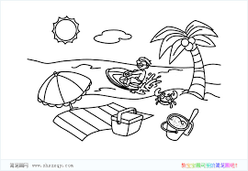
（ ）39. According to the reading , which place do Ken and Sam visit ? according to 根據
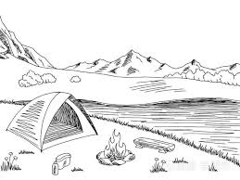
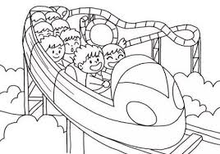
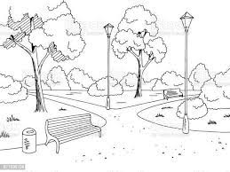
(A) (B) (C) (D)

（ ）40. Which is right?
(A) They don’t like to go the beach. (B) They go to Kenting a week away.
(C) Ken and Sam are brothers. (D) Ken and Sam go to Kenting on May 13.
Dear Ben ,
How are you going? I received a letter from Uncle Bill yesterday. He wants us to visit him in America for Christmas.
In America, Christmas is on December twenty-fifth, and everyone has a big dinner with their family or friends. On this special day, people always give gifts each other. We can see a lot of beautiful Christmas trees on the streets.
Uncle Bill is very happy because he doesn’t need to work that day. He plans to take us to the department store and the museum near his house. After that, at his house, his wife, Aunt Tina, will prepare delicious pancakes, fruit cakes, pizzas and cold drinks for us. We will have a lot of wonderful days there. Now I can’t wait to visit them. They are also looking forward to our arrival! Can you go with me? Waiting for your reply!
Love
Ken
received 收到 visit 拜訪 holiday 假日 be looking forward to期待 arrival到來 reply回覆
（ ）41. Who lives in America?
(A) Roger. (B) Ken. (C) Uncle Ben. (D) Uncle Bill.
（ ）42. Which is true about Ken?
(A) He is happy to visit Uncle Bill. (B) He is Bill’s son.
(C) He can help to make the food. (D) He is going to visit his brother in America.
（ ）43. What’s the date for Christmas?
(A) It’s on the first Monday of December. (B) It’s on the second Monday of December.
(C) It’s on the third Monday of December. (D)It’s on the fourth Monday of December.

(In the department store.)
Sandy：Look! There are lots of beautiful skirts on the second floor. They are so cute. Can we take a look?
Emily：Sure. Let’s go. (On the second floor) Which one do you like?
Sandy：Wow! The pink skirt is really cute and beautiful. I like it a lot. And you?
Emily：Let me see. I like the purple skirt over there.
Sandy：We can wear these skirts to join Anna’s birthday party. We will catch everyone’s eyes at the party.
Emily：Wait! This watch is really fashionable. Can we buy it, too?
Sandy：OK. What about the hats and the shoes?
Emily：They are very special, too. Let’s buy them, too.
Sandy：By the way, do you have enough money?
Emily：Let me check. That’s too bad! We just have money for the skirts. What a pity!
fashionable流行的 skirt 裙子 wear穿 buy 購買 What a pity!真可惜!

（ ）44.Which can the girls buy?
(A) (B) (C) (D)
（ ）45.Why does Emily say “That’s too bad”?
- They are late for party. (B) They don’t like these skirts.
(C) They don’t have enough time. (D) They don’t have enough money.

花蓮縣宜昌國中111年度第二學期第二次段考七年級英語科試題卷
Class: Number: Name: Score:________________
第三部分:非選擇題(每題2分，共10分。)
一、1. When is your birthday ?
.
2. last / the / December / month / the / of / year. / is (重組句子)
.
3. How much flour does John have ? (如右圖回答)
.
4. Our library is big, but their library is small. (請將畫線部分，改成所有格代名詞)
.
5.There are seven days in a week. (請將畫線部分，寫出原問句)
.
【加分題:】每題1分，共7分。

*請用英文寫出正確的日期。
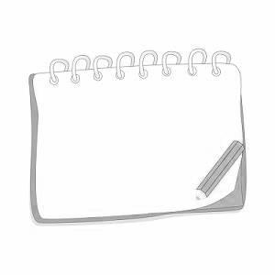 (1)May _____________. 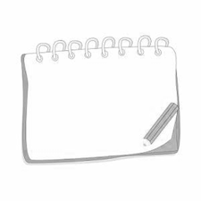(2)March _____________.
三月三十日
五月九日
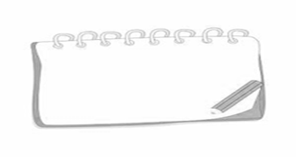(3)__________ fifteenth.
七月十五日
*請在空格處填入正確的答案(計量詞)。
範例: 一杯的奶茶 → One cup of milk tea.
(4)三碗麵 →three of noodles | (6)兩袋米 →two of rice
(5)五罐蘋果汁 →five of apple juice | (7)六片披薩 →six of pizza

