宜昌國中104下學期八年級第一次段考口說測驗
- 朗讀：三選一
- The gray MP3 player is lighter than the purple one.
- Mark is the happiest farmer in the world.
- The monkeys in the zoo look funny.
二、 回答問題：六選四 (部分題目請老師準備例圖。)
題目 | 參考答案
- Which line is longer, the left one or the right one? (看圖回答。) | The _______ one is longer.
- How would the ma’am like to pay for the MP3 player? (看圖回答。) | She’d like to _________________
- Which smartphone is the most expensive? (看圖回答。) | The _________ is the most expensive.
- What’s your best subject at school?  (根據事實回答。) | ____________ is my best subject.
- What do people in America do on Easter? | They paint eggs in beautiful colors and have an egg hunt.
- How does the boy look in the special costume? (看圖回答。) | He looks ________________.

For question 1 For question 2




For question 3
ePhone eaT Sorry
NT$9,500 NT$11,000 NT$21,000
eaT

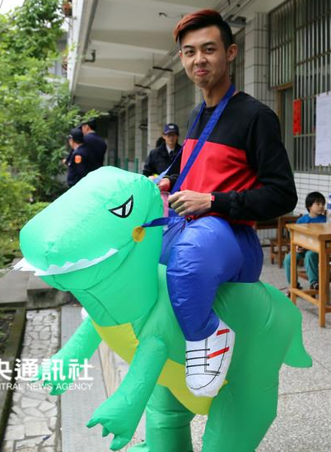
For question 6

