**宜昌國中113年暑假學習任務-「祖父母或外祖父母生命故事」**

各位同學，你(妳)是否聽過「家有一老，如有一寶」這句話呢? 家中的長輩有豐富的生命經驗，值得我們去學習，但往往我們卻缺乏機會去好好聆聽屬於他們的生命故事，本次暑假期間，請你和家人一起討論，以「祖父母或外祖父母生命故事」為主題，尋找祖父母或外祖父母的舊照片，並向祖父母或其它長輩詢問舊照背後的故事，搭配舊照撰寫生命故事。(字數約200~300字（含標題、標點符號）)

照片主題可為出生、童年、入學、畢業、成年禮、從軍、結婚、工作、全家福、年夜飯、旅遊等日常生活或儀式場合。照片中人物須含祖父或祖母，若為團體照，須於圖說文字標註祖父母。學習單作品可以紙本方式(貼上照片)或以電子檔方式繳交。本次作業於開學日繳交至導師後，將在「關懷你和我」課程中發表，由導師及同學選出優良作品，獲選之同學將給予記嘉獎一次的獎勵喔。 (本學習單之電子檔請至學校網頁下載)

(附註：若祖父母無法聯繫，可以家中其他長輩的生命故事替代。)

範例：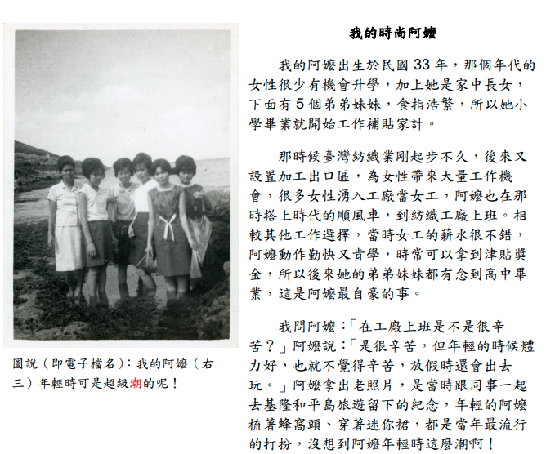

|  |
| --- |
| （本範例故事屬虛構，照片取自文化部國家文化記憶庫，由張淑惠小姐提供、新北市政府文化局建檔） |

|  |  |  |  |  |  |
| --- | --- | --- | --- | --- | --- |
| 班級 |  | 姓名 |  | 座號 |  |

|  |  |  |  |  |  |  |  |  |  |  |  |  |  |  |  |  |  |  |  |  |  |  |  |  |  |  |  |  |  |  |  |  |  |  |  |  |  |  |  |  |  |  |  |  |  |  |  |  |  |  |  |  |  |  |  |  |  |  |  |  |  |  |  |  |  |  |  |  |  |  |  |  |  |  |  |  |  |  |  |  |  |  |  |  |  |  |  |  |  |  |  |  |  |  |  |  |  |  |  |  |  |  |  |  |  |  |  |  |  |  |  |  |  |  |  |  |  |  |  |  |  |  |  |  |  |  |  |  |  |  |  |  |  |  |  |  |  |  |  |  |  |  |  |  |  |  |  |  |  |  |  |  |  |  |  |  |  |  |  |  |  |  |  |  |  |  |  |  |  |  |  |  |  |  |  |  |  |  |  |  |  |  |  |  |  |  |  |  |  |  |  |  |  |  |  |  |  |  |  |  |  |  |  |  |  |  |  |  |  |  |  |  |  |  |  |  |  |  |  |  |  |  |  |  |  |  |  |  |  |  |  |  |  |  |  |  |  |  |  |  |  |  |  |  |  |  |  |  |  |  |  |  |  |  |  |  |  |  |  |  |  |  |  |  |  |  |  |  |  |  |  |  |  |  |  |  |  |  |  |  |  |  |  |  |  |  |  |  |  |  |  |  |  |  |  |  |  |  |  |  |
| --- | --- | --- | --- | --- | --- | --- | --- | --- | --- | --- | --- | --- | --- | --- | --- | --- | --- | --- | --- | --- | --- | --- | --- | --- | --- | --- | --- | --- | --- | --- | --- | --- | --- | --- | --- | --- | --- | --- | --- | --- | --- | --- | --- | --- | --- | --- | --- | --- | --- | --- | --- | --- | --- | --- | --- | --- | --- | --- | --- | --- | --- | --- | --- | --- | --- | --- | --- | --- | --- | --- | --- | --- | --- | --- | --- | --- | --- | --- | --- | --- | --- | --- | --- | --- | --- | --- | --- | --- | --- | --- | --- | --- | --- | --- | --- | --- | --- | --- | --- | --- | --- | --- | --- | --- | --- | --- | --- | --- | --- | --- | --- | --- | --- | --- | --- | --- | --- | --- | --- | --- | --- | --- | --- | --- | --- | --- | --- | --- | --- | --- | --- | --- | --- | --- | --- | --- | --- | --- | --- | --- | --- | --- | --- | --- | --- | --- | --- | --- | --- | --- | --- | --- | --- | --- | --- | --- | --- | --- | --- | --- | --- | --- | --- | --- | --- | --- | --- | --- | --- | --- | --- | --- | --- | --- | --- | --- | --- | --- | --- | --- | --- | --- | --- | --- | --- | --- | --- | --- | --- | --- | --- | --- | --- | --- | --- | --- | --- | --- | --- | --- | --- | --- | --- | --- | --- | --- | --- | --- | --- | --- | --- | --- | --- | --- | --- | --- | --- | --- | --- | --- | --- | --- | --- | --- | --- | --- | --- | --- | --- | --- | --- | --- | --- | --- | --- | --- | --- | --- | --- | --- | --- | --- | --- | --- | --- | --- | --- | --- | --- | --- | --- | --- | --- | --- | --- | --- | --- | --- | --- | --- | --- | --- | --- | --- | --- | --- | --- | --- | --- | --- | --- | --- | --- | --- | --- | --- | --- | --- | --- | --- | --- | --- | --- | --- | --- | --- | --- | --- | --- | --- | --- | --- | --- | --- | --- | --- | --- | --- | --- | --- |
| |  |  |  |  |  |  |  |  |  |  |  |  |  |  |  | | --- | --- | --- | --- | --- | --- | --- | --- | --- | --- | --- | --- | --- | --- | --- | |  |  |  |  |  |  |  |  |  |  |  |  |  |  |  | |  |  |  |  |  |  |  |  |  |  |  |  |  |  |  | |  |  |  |  |  |  |  |  |  |  |  |  |  |  |  | |  |  |  |  |  |  |  |  |  |  |  |  |  |  |  | |  |  |  |  |  |  |  |  |  |  |  |  |  |  |  | |  |  |  |  |  |  |  |  |  |  |  |  |  |  |  | |  |  |  |  |  |  |  |  |  |  |  |  |  |  |  | |  |  |  |  |  |  |  |  |  |  |  |  |  |  |  | |  |  |  |  |  |  |  |  |  |  |  |  |  |  |  | |  |  |  |  |  |  |  |  |  |  |  |  |  |  |  | |  |  |  |  |  |  |  |  |  |  |  |  |  |  |  | |  |  |  |  |  |  |  |  |  |  |  |  |  |  |  | |  |  |  |  |  |  |  |  |  |  |  |  |  |  |  | |  |  |  |  |  |  |  |  |  |  |  |  |  |  |  | |  |  |  |  |  |  |  |  |  |  |  |  |  |  |  | |  |  |  |  |  |  |  |  |  |  |  |  |  |  |  | |  |  |  |  |  |  |  |  |  |  |  |  |  |  |  | |  |  |  |  |  |  |  |  |  |  |  |  |  |  |  | |  |  |  |  |  |  |  |  |  |  |  |  |  |  |  | |  |  |  |  |  |  |  |  |  |  |  |  |  |  |  | |
|  |

|  |  |  |  |  |
| --- | --- | --- | --- | --- |
| 請附上照片(至多兩張) | | | | |
| 導師簽章： | |  | 輔導室簽章： |  |